**ABSTRACT**

The **Online Examination System** is a web-based platform developed to automate and streamline the process of conducting examinations online. The system provides a secure, flexible, and efficient method for managing exams, question banks, students, and results. It enables administrators and teachers to create and schedule exams, add questions, and monitor performance, while allowing students to log in, take tests, and view results in real time.

This project includes user roles such as Admin, Teacher, and Student. The Admin can manage users and system-wide settings, Teachers can create exams and evaluate performance, and Students can take exams within the assigned time slots. The system supports objective (MCQ) type questions and auto-evaluation of results for immediate feedback.

The database design ensures data integrity and supports scalable management of users, subjects, exams, questions, answers, and scores. This system reduces paperwork, eliminates manual errors, and enhances transparency and accessibility in the examination process.

**Key Features**

1. **User Authentication & Roles**
   * Secure login for Admin, Teachers, and Students
   * Role-based access control
2. **Exam Creation & Management**
   * Teachers can create exams with title, subject, and schedule
   * Option to set duration and exam availability
3. **Question Bank**
   * Support for MCQs (Multiple Choice Questions)
   * Add/edit/delete questions for each exam
   * Auto-evaluation using correct answers
4. **Online Exam Interface for Students**
   * User-friendly layout
   * Timer functionality during exams
   * Instant submission of answers
5. **Auto-Grading and Result Generation**
   * Automatic score calculation based on correct answers
   * Results stored and displayed to students immediately
6. **Result Reports**
   * View score reports per exam or per student
   * Export options (PDF/Excel – optional in advanced version)
7. **Subject Management**
   * Admin/teachers can add and assign subjects to exams
   * Categorized question and exam structure
8. **Activity Logs / History (Optional Advanced Feature)**
   * Tracks login, attempts, and result history

**Key Concepts Used**

* Relational Database Management (MySQL)
* Entity-Relationship Modeling (ER Model)
* CRUD Operations (Create, Read, Update, Delete)
* Normalization of Data
* Joins and Subqueries in SQL

**INTRODUCTION**

In today’s digital era, educational institutions are increasingly adopting technology-driven methods to improve academic processes. One such critical area is the management and conduction of examinations. Traditional paper-based examinations are often time-consuming, resource-intensive, and prone to human error. To overcome these challenges, an **Online Examination System** provides an efficient and scalable solution.

This project aims to design and develop a web-based application that automates the examination process, ensuring ease of access, transparency, and accuracy. The system supports multiple user roles such as **Admin**, **Teacher**, and **Student**, each with defined functionalities. Admins can manage users and subjects, teachers can create exams and questions, and students can take exams and view results.

By leveraging a relational database management system (RDBMS), the platform ensures secure and reliable storage of user data, questions, exam records, and results. Auto-evaluation of multiple-choice questions allows students to receive instant feedback on their performance.

The system not only simplifies exam administration but also enhances student engagement and accessibility, especially in remote learning environments. It is a step forward in embracing digital transformation in the education sector.

**PROJECT OVERVIEW**

The Online Examination System is a database-driven application designed to manage and conduct academic examinations through a digital interface. It aims to replace the traditional paper-based exam process with a streamlined and secure online platform that ensures efficiency, accuracy, and scalability.

The system enables educational institutions to conduct exams from anywhere, at any time, while maintaining integrity and speed. It consists of three main modules: Admin, Teacher, and Student — each with specific access and responsibilities. The Admin oversees user management and system settings, Teachers are responsible for exam creation and question management, and Students participate in exams and view their scores.

All exam questions are stored in a centralized question bank categorized by subject. Exams can be scheduled with specific start and end times, and automatic grading is implemented for multiple-choice questions. The results are stored in the database and are made available to students immediately after submission.

This system is especially useful in institutions aiming for online learning, remote assessments, and automated result processing. The database ensures relational integrity, data security, and efficient querying to handle various operations such as login validation, exam scheduling, scoring, and result generation. **TYPES OF USERS**

The Online Examination System is designed with **role-based access control**, meaning each user type has specific permissions and functionalities. There are **three main types of users** in the system:

**1. Admin**

**Responsibilities:**

* Manage all users (Add/Edit/Delete)
* Assign roles (student or teacher)
* Manage subjects and system settings
* Monitor overall system activity

**Access Rights:**

* Full access to all modules and data
* Can view all exam records and results
* Controls system-level configurations

**2. Teacher**

**Responsibilities:**

* Create, update, and delete exams
* Add questions to the question bank
* Set exam duration and availability
* View results of students who took their exams

**Access Rights:**

* Access only exams and questions created by them
* View student performance and scores

**3. Student**

**Responsibilities:**

* View available exams
* Take online exams within scheduled time
* Submit answers and view instant results
* Review past exam history (optional feature)

**Access Rights:**

* Limited to their own exam activity and results
* Cannot view or edit exams/questions
* Authentication & Role-Based Access
* Front-end/Back-end Integration (Optional in Full Stack)
* Client-Server Architecture

**OBJECTIVE**

The main objective of the Online Examination System is to design and develop a user-friendly, efficient, and secure platform that automates the process of conducting exams, evaluating responses, and generating results in real time.

Specific Objectives:

1. To automate the examination process  
   Reduce manual work by digitizing question paper creation, answer collection, and result calculation.
2. To support multiple user roles  
   Provide role-based access for Admins, Teachers, and Students, ensuring controlled and secure system usage.
3. To enable easy exam creation and scheduling  
   Allow teachers to create subject-wise exams with time constraints and question banks.
4. To provide an interactive exam interface for students  
   Deliver a smooth and accessible UI for students to attempt online tests within the assigned duration.
5. To auto-evaluate multiple-choice questions  
   Instantly calculate scores based on pre-defined correct answers to ensure speed and accuracy.
6. To generate and store exam results efficiently  
   Maintain detailed exam history and score reports for future reference and performance tracking.
7. To ensure data integrity and security  
   Use a robust database system to manage users, questions, exams, and results with relational integrity.

**Designing**

**Entity-Relationship (ER) Diagram**

The ER Diagram is a visual representation of the data model for the Online Examination System. It defines the key entities, their attributes, and relationships among them. The system follows a relational approach, ensuring data integrity and efficient handling of users, exams, and results.

Main Entities and Their Descriptions:

| Entity | Attributes |
| --- | --- |
| Users | user_id (PK), name, email, password, role (admin, teacher, student) |
| Subjects | subject_id (PK), subject_name |
| Exams | exam_id (PK), title, subject_id (FK), created_by (FK), start_time, end_time |
| Questions | question_id (PK), exam_id (FK), question_text, type, option_a, option_b, option_c, option_d, correct_answer |
| Answers | answer_id (PK), student_id (FK), question_id (FK), selected_option |
| Results | result_id (PK), student_id (FK), exam_id (FK), score, submitted_at |

🔗 Relationships:

* One User can create many Exams (Teacher role)
* One Subject can be linked to many Exams
* One Exam contains many Questions
* One Student (User) can attempt many Exams and submit Answers
* Each Answer is linked to a Question and a Student
* Results summarize the score of a student for a specific Exam

**ER Diagram**

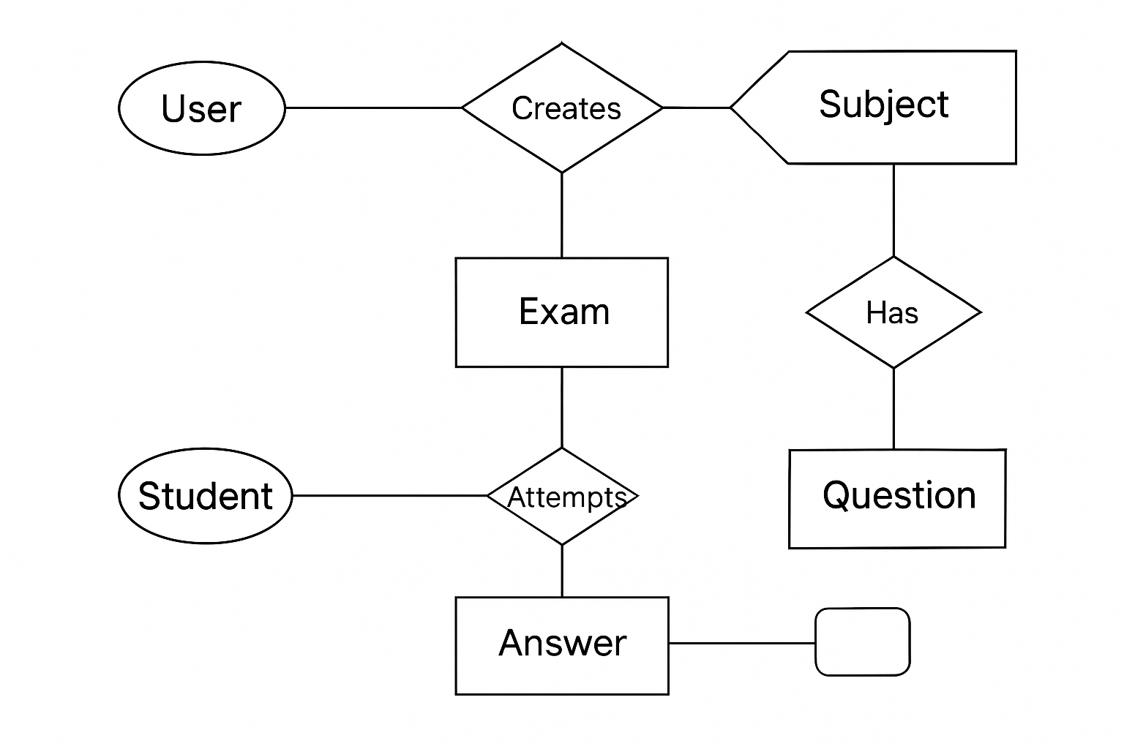

**Database**

**Relational Schema Diagram**

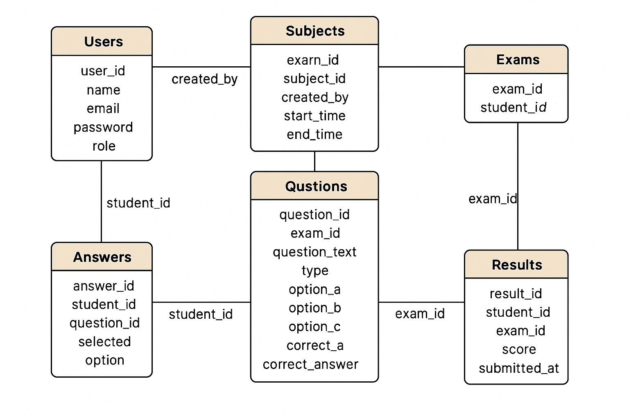

**Database**

Below is the tabular form of the main and supporting tables used in the Online Examination System, including fields, data types, keys, and relationships.

1. **Users**

|  |  |  |
| --- | --- | --- |
| Column Name | Data Type | Description |
| UserID | INT | Unique User ID (Primary Key) |
| Name | VARCHAR(100) | Full name of the user |
| Email | VARCHAR(100) | Email address |
| Password | VARCHAR(255) | Hashed password |
| Role | ENUM | Role (admin, teacher, student) |
| CreatedAt | DATETIME | Account creation date/time |

**2. Roles**

|  |  |  |
| --- | --- | --- |
| **Column Name** | **Data Type** | **Description** |
| RoleID | INT | Role ID (Primary Key) |
| RoleName | VARCHAR(50) | Role name |

**3. Subjects**

|  |  |  |
| --- | --- | --- |
| **Column Name** | **Data Type** | **Description** |
| SubjectID | INT | Subject ID (Primary Key) |
| SubjectName | VARCHAR(100) | Name of the subject |

**4. Exams**

|  |  |  |
| --- | --- | --- |
| **Column Name** | **Data Type** | **Description** |
| ExamID | INT | Exam ID (Primary Key) |
| Title | VARCHAR(100) | Title of the exam |
| SubjectID | INT | FK to Subjects |
| CreatedBy | INT | FK to Users (creator) |
| StartTime | DATETIME | Exam start time |
| EndTime | DATETIME | Exam end time |
| TotalMarks | INT | Total marks of the exam |

**5. Questions**

|  |  |  |
| --- | --- | --- |
| **Column Name** | **Data Type** | **Description** |
| QuestionID | INT | Question ID (Primary Key) |
| ExamID | INT | FK to Exams |
| QuestionText | TEXT | The question text |
| Type | VARCHAR(20) | Type of question (e.g., MCQ) |
| OptionA | VARCHAR(255) | Option A |
| OptionB | VARCHAR(255) | Option B |
| OptionC | VARCHAR(255) | Option C |
| OptionD | VARCHAR(255) | Option D |
| CorrectAnswer | CHAR(1) | Correct answer (A/B/C/D) |

**6. Answers**

|  |  |  |
| --- | --- | --- |
| **Column Name** | **Data Type** | **Description** |
| AnswerID | INT | Answer ID (Primary Key) |
| StudentID | INT | FK to Users |
| QuestionID | INT | FK to Questions |
| SelectedOption | CHAR(1) | Selected answer |
| AnswerTime | DATETIME | Time of submission |

**7.Results**

|  |  |  |
| --- | --- | --- |
| **Column Name** | **Data Type** | **Description** |
| ResultID | INT | Result ID (Primary Key) |
| StudentID | INT | FK to Users |
| ExamID | INT | FK to Exams |
| Score | INT | Marks obtained |
| SubmittedAt | DATETIME | Submission date/time |
| Status | VARCHAR(20) | Result status (e.g., Pass/Fail) |

**Coding (Queries)**

* **Table Creation Scripts**
* The CRE ATE TABLE statements are used to create the database tables. These scripts define the schema of each table, including column names, data types, and constraints.

**Users Table**

CREATE TABLE Users (

UserID INT PRIMARY KEY AUTO_INCREMENT,

Name VARCHAR(100),

Email VARCHAR(100) UNIQUE,

Password VARCHAR(255),

Role ENUM('admin', 'teacher', 'student'),

CreatedAt DATETIME DEFAULT CURRENT_TIMESTAMP

);

**2. Roles Table**

CREATE TABLE Users (

UserID INT PRIMARY KEY AUTO_INCREMENT,

Name VARCHAR(100),

Email VARCHAR(100) UNIQUE,

Password VARCHAR(255),

Role ENUM('admin', 'teacher', 'student'),

CreatedAt DATETIME DEFAULT CURRENT_TIMESTAMP

);

**3. Subjects Table**

CREATE TABLE Subjects (

SubjectID INT PRIMARY KEY AUTO_INCREMENT,

SubjectName VARCHAR(100) NOT NULL

);

**4. Exams Table**

CREATE TABLE Exams (

ExamID INT PRIMARY KEY AUTO_INCREMENT,

Title VARCHAR(100),

SubjectID INT,

CreatedBy INT,

StartTime DATETIME,

EndTime DATETIME,

TotalMarks INT,

FOREIGN KEY (SubjectID) REFERENCES Subjects(SubjectID),

FOREIGN KEY (CreatedBy) REFERENCES Users(UserID)

);

**5. Questions Table**

CREATE TABLE Questions (

QuestionID INT PRIMARY KEY AUTO_INCREMENT,

ExamID INT,

QuestionText TEXT,

Type VARCHAR(20),

OptionA VARCHAR(255),

OptionB VARCHAR(255),

OptionC VARCHAR(255),

OptionD VARCHAR(255),

CorrectAnswer CHAR(1),

FOREIGN KEY (ExamID) REFERENCES Exams(ExamID)

);

**6. Answers Table**

CREATE TABLE Answers (

AnswerID INT PRIMARY KEY AUTO_INCREMENT,

StudentID INT,

QuestionID INT,

SelectedOption CHAR(1),

AnswerTime DATETIME,

FOREIGN KEY (StudentID) REFERENCES Users(UserID),

FOREIGN KEY (QuestionID) REFERENCES Questions(QuestionID)

);

**7.Results Table**

CREATE TABLE Results (

ResultID INT PRIMARY KEY AUTO_INCREMENT,

StudentID INT,

ExamID INT,

Score INT,

SubmittedAt DATETIME,

Status VARCHAR(20),

FOREIGN KEY (StudentID) REFERENCES Users(UserID),

FOREIGN KEY (ExamID) REFERENCES Exams(ExamID)

);

**Data Insertion Queries**

* The INSER T INTO statements are used to insert sample data into the tables. These queries populate the database with initial data for testing and demonstration purposes .

SELECT e.title, COUNT(q.question_id) AS total_questions

FROM Exams e

LEFT JOIN Questions q ON e.exam_id = q.exam_id

GROUP BY e.exam_id;

SELECT u.name, r.score

FROM Results r

JOIN Users u ON r.student_id = u.user_id

JOIN Exams e ON r.exam_id = e.exam_id

WHERE e.title = 'Math Quiz 1';

SELECT u.name AS teacher_name, e.title AS exam_title

FROM Exams e

JOIN Users u ON e.created_by = u.user_id

WHERE u.role = 'teacher';

SELECT MAX(score) AS highest_score

FROM Results r

JOIN Exams e ON r.exam_id = e.exam_id

WHERE e.title = 'CS Basics Test';

SELECT u.name, q.question_text, a.selected_option

FROM Answers a

JOIN Users u ON a.student_id = u.user_id

JOIN Questions q ON a.question_id = q.question_id

JOIN Exams e ON q.exam_id = e.exam_id

WHERE e.title = 'Physics Intro';

SELECT e.title, e.start_time, e.end_time

FROM Exams e

JOIN Subjects s ON e.subject_id = s.subject_id

WHERE s.subject_name = 'Mathematics';

**Outputs**

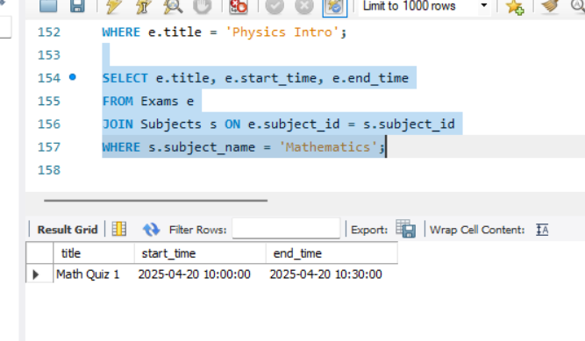

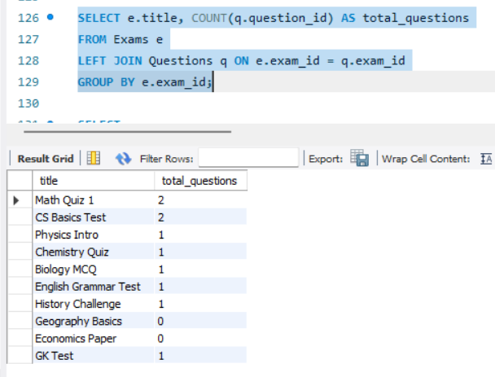

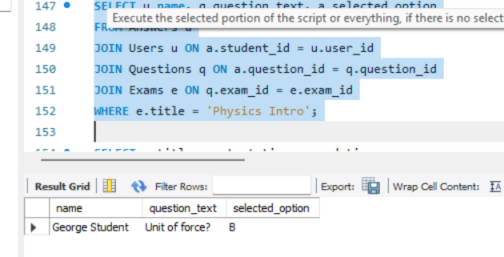

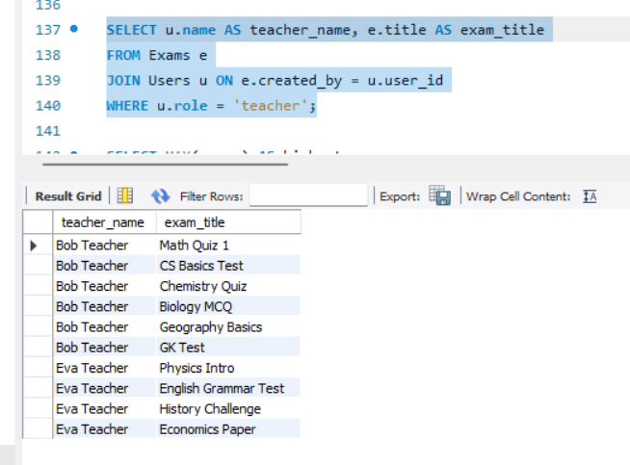



**Functional Output Summary**

The Examination database is designed to manage an online examination system with comprehensive functionalities. It includes six key tables: Users, Subjects, Exams, Questions, Answers, and Results. The Users table stores details of all users with defined roles such as admin, teacher, and student. The Subjects table lists academic subjects such as Mathematics, Computer Science, Physics, and others. The Exams table connects to both Subjects and Users, indicating the subject of each exam and the teacher who created it, along with start and end times.

The Questions table stores questions related to each exam, supporting both multiple-choice and short-answer formats, with options A to D and the correct answer specified. The Answers table logs each student’s responses to exam questions, while the Results table summarizes their scores and submission times.

This structure supports key functionalities such as retrieving student scores for specific exams, listing exams created by each teacher, analyzing exam statistics like the number of questions or highest scores, and tracking student responses. It also enables filtering exams by subject, identifying high-performing students, and reviewing full exam content. The schema provides a clear, relational framework for managing and analyzing online assessments efficiently**.**

**Key Highlights:**

Role-Based User Management: Supports admins, teachers, and students with unique access and roles.

Comprehensive Subject List: Includes 10 diverse subjects like Mathematics, CS, Physics, and more.

Exam Management: Teachers can create exams with start/end times, linked to specific subjects.

Question Flexibility: Supports both multiple-choice and short-answer questions with detailed options and correct answers.

Answer Tracking: Captures students’ selected answers for every question attempted.

Result Summary: Stores scores and submission timestamps for performance tracking.

Query Ready: Enables student performance reports, teacher exam contributions, and exam analytics.

Data Relationships: Robust use of foreign keys ensures data consistency across exams, users, questions, and results.

Scalable Design: Easily extendable for more users, subjects, exams, or question types.

**Conclusion:**

The Examination database is a well-structured and scalable system designed to efficiently manage online assessments. It provides a robust framework that connects users, subjects, exams, questions, answers, and results in a relational manner. With role-based access, flexible question types, and comprehensive tracking of student performance, the system ensures clarity, consistency, and functionality. It supports detailed reporting and analytics, making it suitable for educational institutions aiming to digitize and streamline their examination processes. Overall, this database offers a solid foundation for building a full-fledged online examination platform.